**Progressive Web App**

Building the web applications of tomorrow that flawlessly blend into native app-like design and interface.

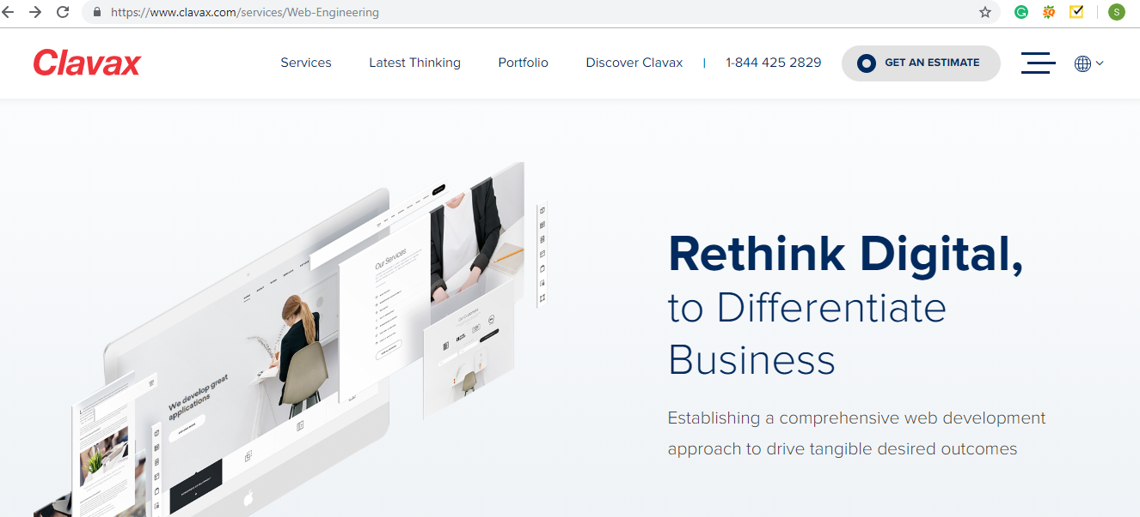

**Next>>**

Nunc Systems creates web apps which are secure and fast loading web pages. Progressive web applications built by us ensure seamless performance, identical to that of native mobile application. With a goal to increase user engagement, Nunc Systems creates web apps that run faster across all platforms. We integrate unique features such as offline browsing, push notification, data analysis and easy distribution channels into web apps.

**Next>>**

**Benefits of PWA**

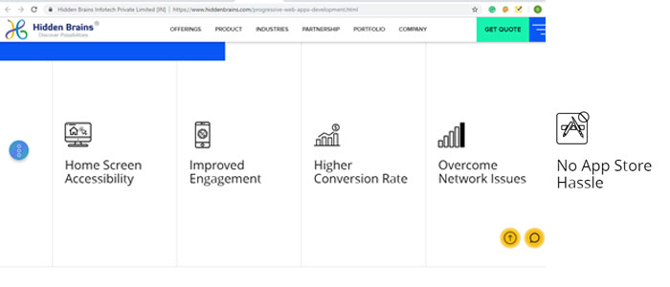

Progressive web apps have higher engagement and also focus on speed lowers bounce rates and increases the number of monthly active users. Gives the best experience in the modern web and also cost-effective.

The best part about having Progressive Web Applications is it works fine even during the poor connection, on all devices and all browsers.

Progressive Web Apps do not need specific installation and Increase conversion by focusing on native features of modern web

**Get a Quote**

